ОЧЕРЕДНОЕ СУКА ГАВНО ЕБАНОЕ В ЭТОМ АКСЕСЕ СУКА БЛЯДСКОМ

**3.6**  
  
SELECT s.student_id, s.univ_id, s.surname, s.name, s.kurs, u.univ_name, subj.subj_name

FROM student s

INNER JOIN university u ON s.univ_id = u.univ_id

INNER JOIN exam_marks em ON s.student_id = em.student_id

INNER JOIN subj_lect sl ON em.subj_id = sl.subj_id

INNER JOIN subject subj ON sl.subj_id = subj.subj_id

WHERE s.kurs = 1;

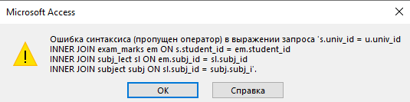

**4.2**

CREATE TABLE subject (

subj_id INT PRIMARY KEY,

subj_name VARCHAR(255) NOT NULL,

hour INT NOT NULL DEFAULT 36,

semestr INT NOT NULL CHECK (semestr BETWEEN 1 AND 12)

);

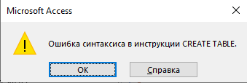  
  
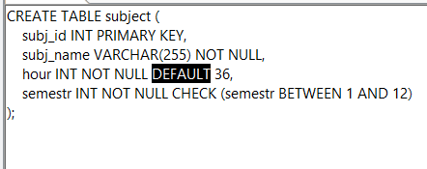

**РЕШИНИЕ 4.3**

